# How to upload reports and close report issues

## Uploading Report Files to the Report Templates

1. On the 1st tab, navigate to the Code Menu, and select the Report Template folder

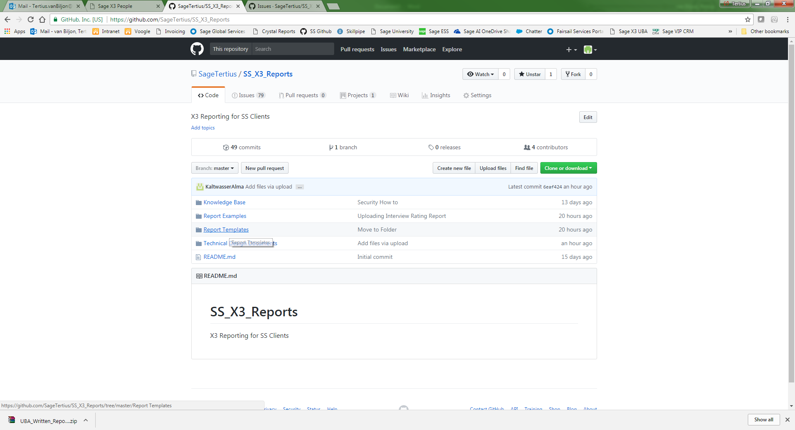

1. Within the Report Templates folder, select the applicable sub section that the report is assigned to

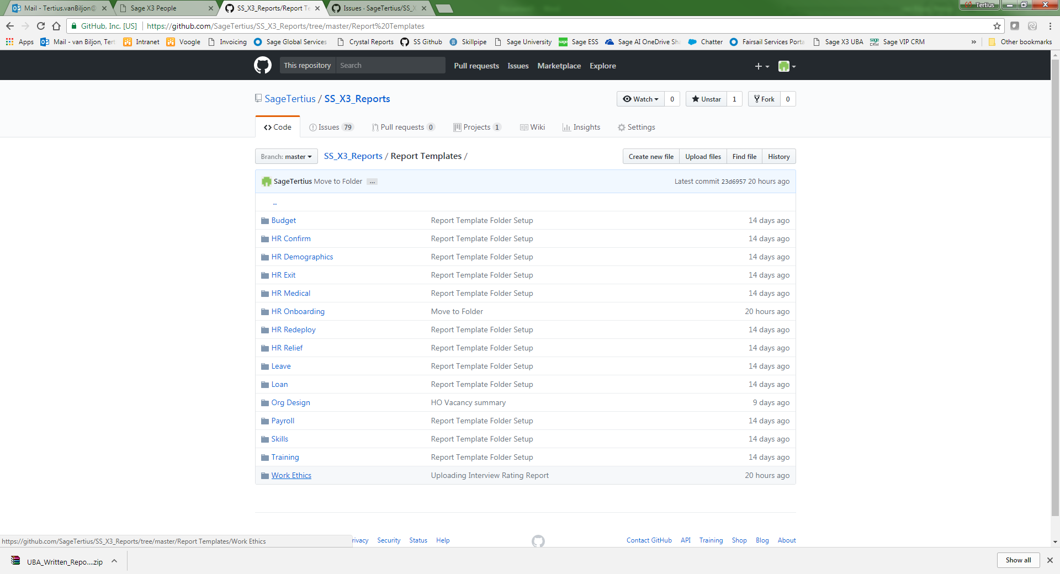

1. Within the sub section, select the Upload Files button

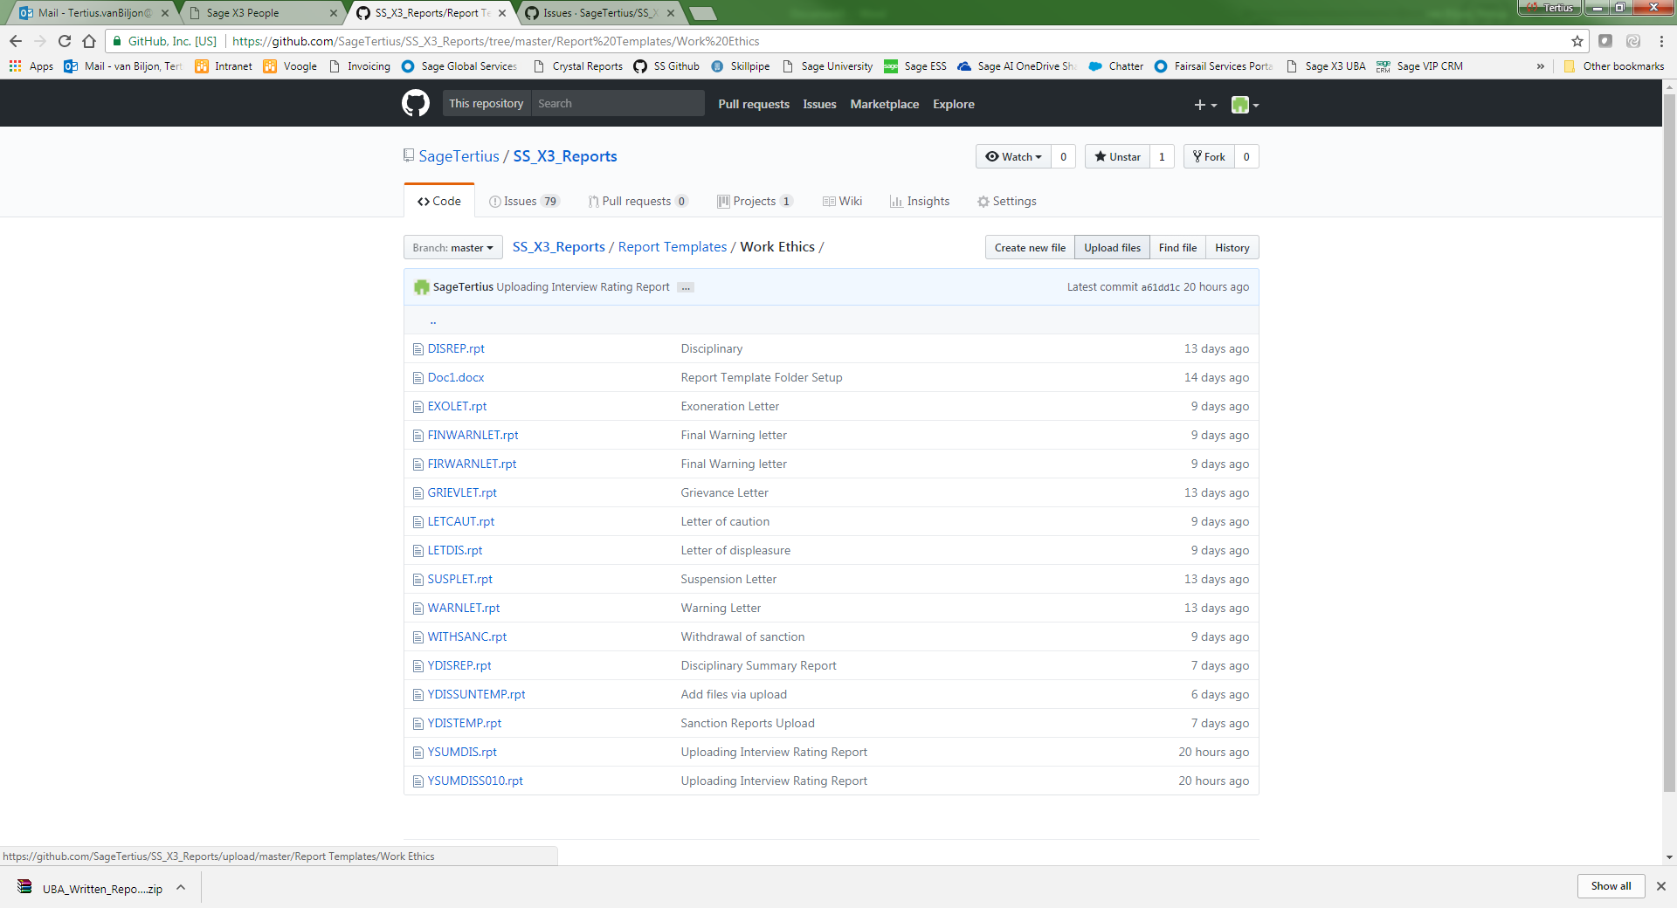

1. On the Upload Files screen, either drag the .rpt file into the drag area, or select the “choose your files” text in order to open a window browser to browse to the .rpt file.

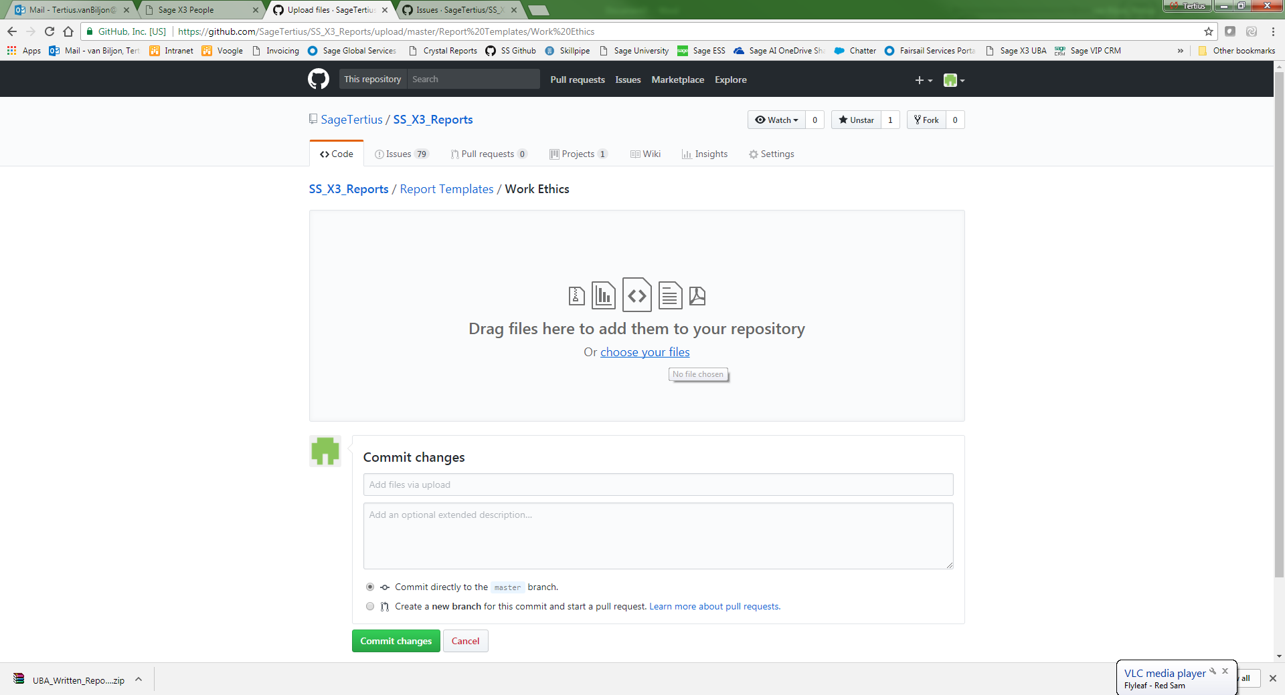

**Note: Multiple files can be uploaded to the sub section at the same time. To do so, drag all of the applicable files into the drag area, or select multiple files through the browser option.

1. Once the file has completed the upload, a commit change must be done before the file will be fully uploaded to the repository. To do this, type in a small heading to detail the action being performed eg: Upload of report. No detail is required, unless there are special circumstances. Make sure that the first radio button is ticked, to make sure the file is uploaded directly to master, and then select the green Commit Changes button

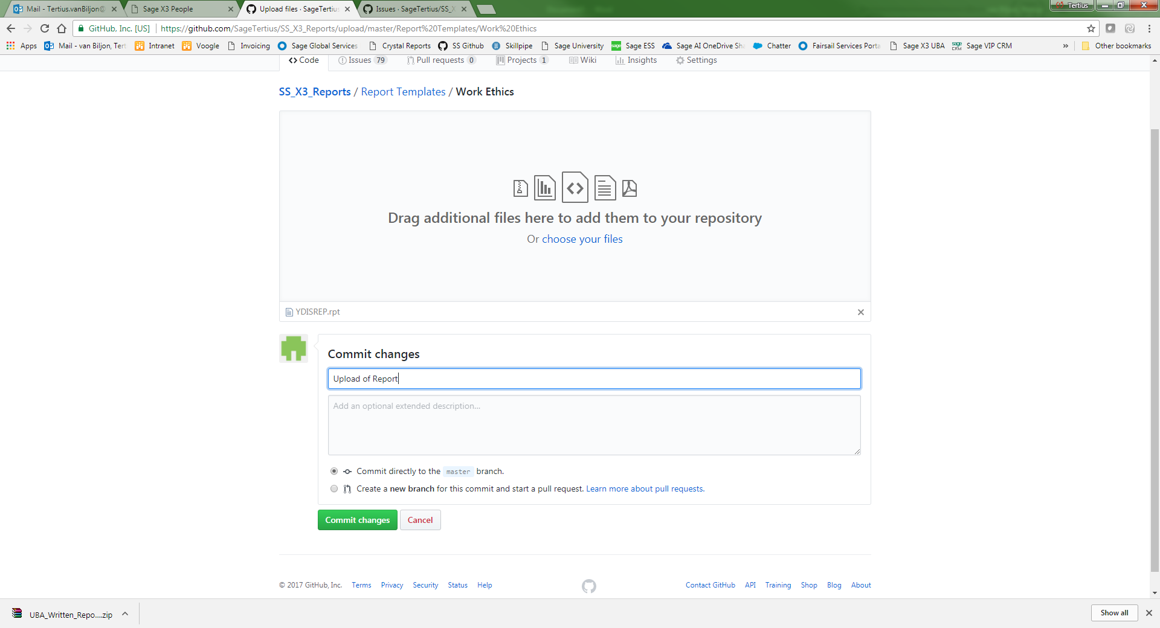

1. With the .rpt file uploaded, the file will now appear under the specific sub section for all users.

## Linking Reports to Issues and Closing Issues

1. Open a second tab so that you have 2 Github screens available
2. On the first tab, navigate to the Code Menu, and to the sub section where the report was uploaded to

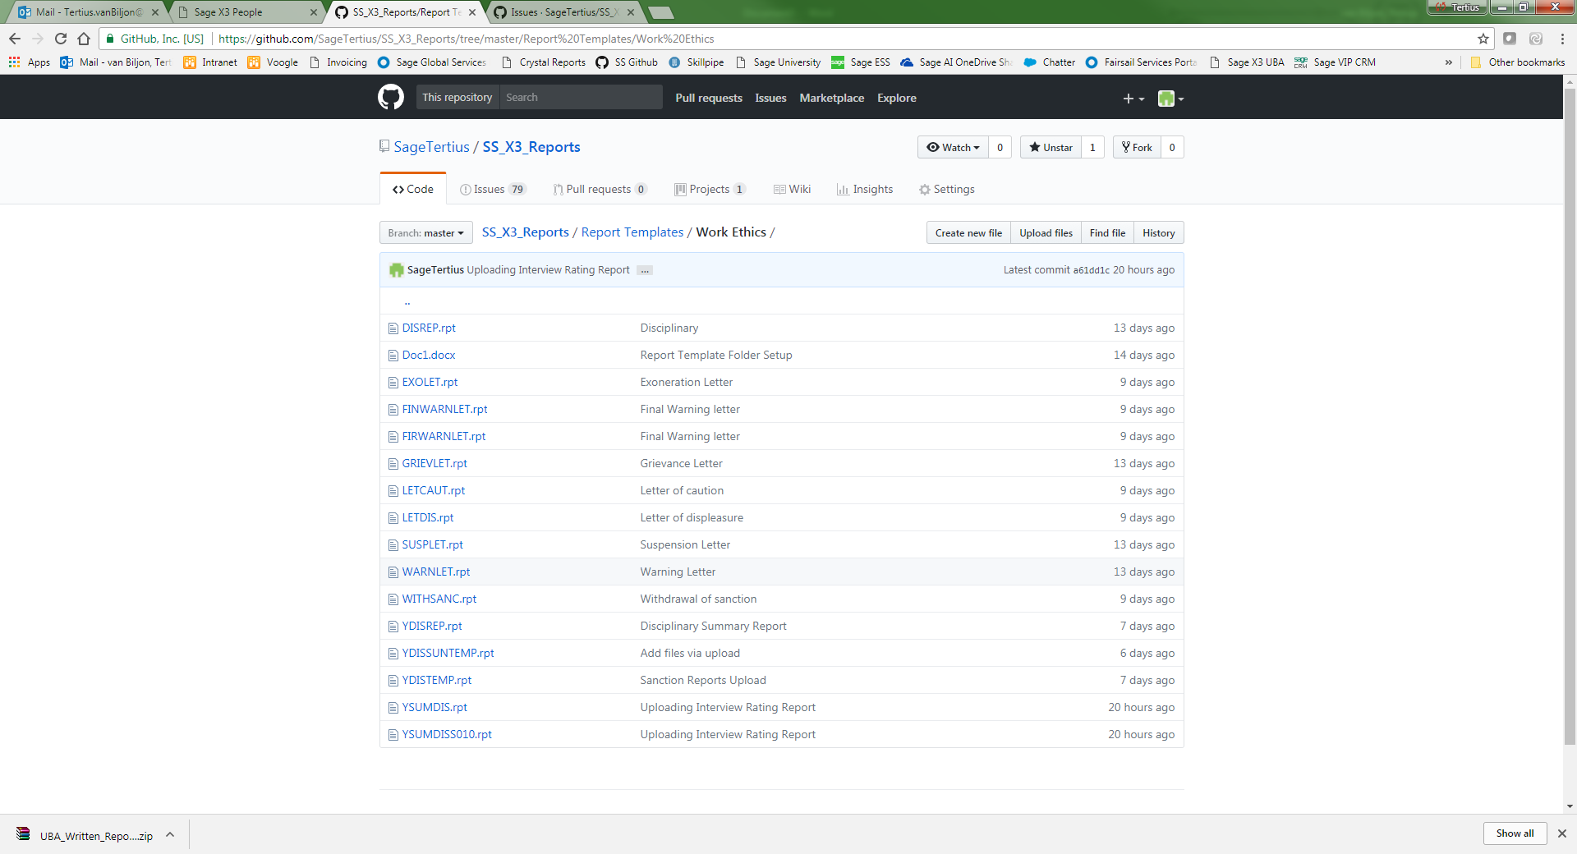

1. Right click on the blue report name, and select to copy the link address

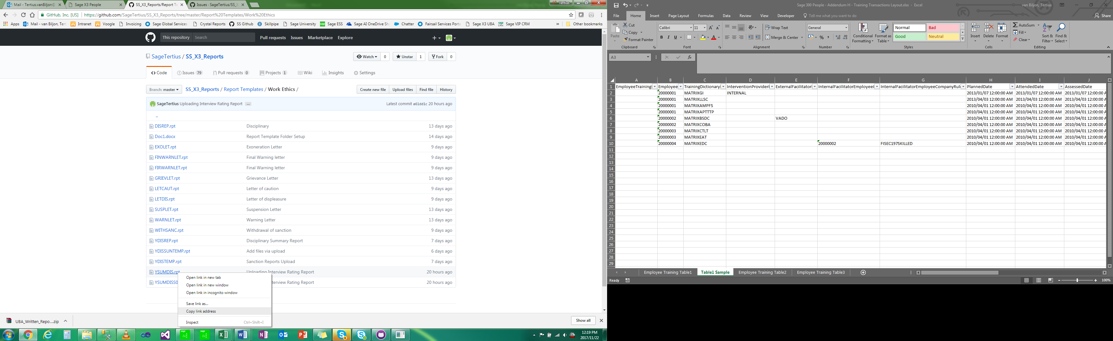

1. With the report link copied, go to the second Github tab
2. Navigate to the Issues Menu and select the Report Issue to be closed

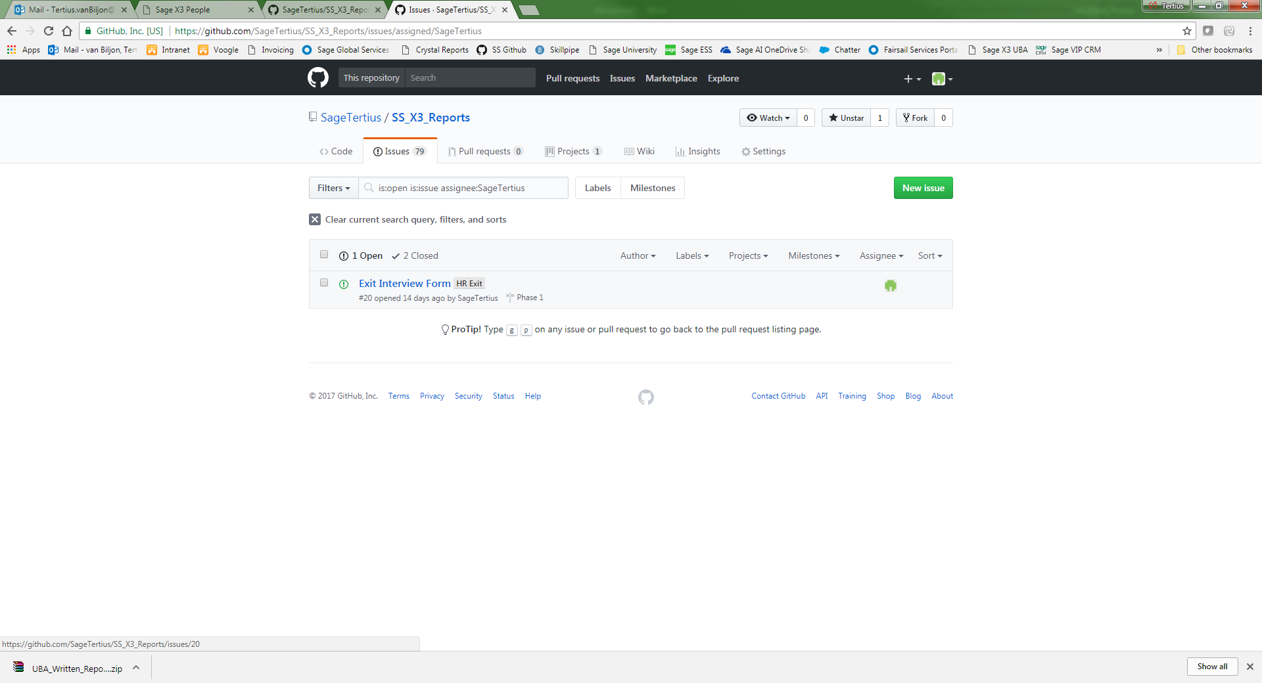

1. In the top right corner of the first comment, select the Pencil button to edit the comment

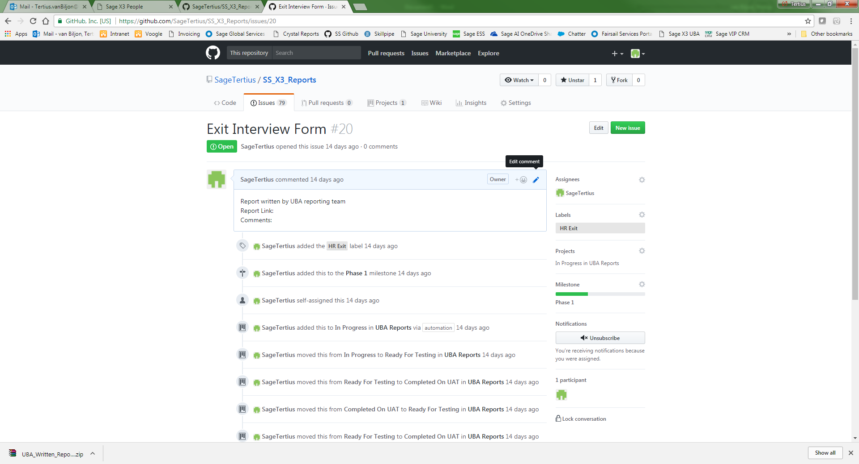

1. Next to the Report Link, select to paste, so that the link address from the previous steps appears. And then select the green Update Comments button

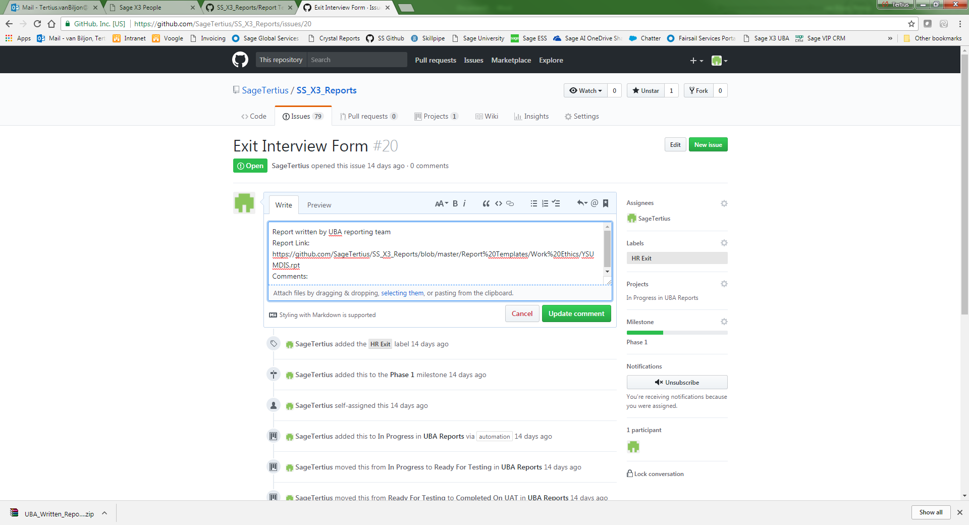

1. With the report link in the heading, scroll to the bottom of the page to find a comment section with the Close Issue button.

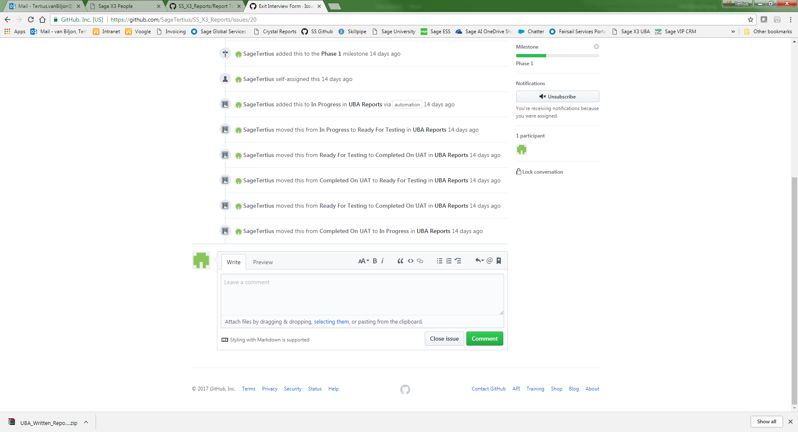

1. If additional information regarding the report is required, this can be placed into the Comment box. Alternatively, just select the Close Issue or Close and Comment button for the report issue to move to the next phase

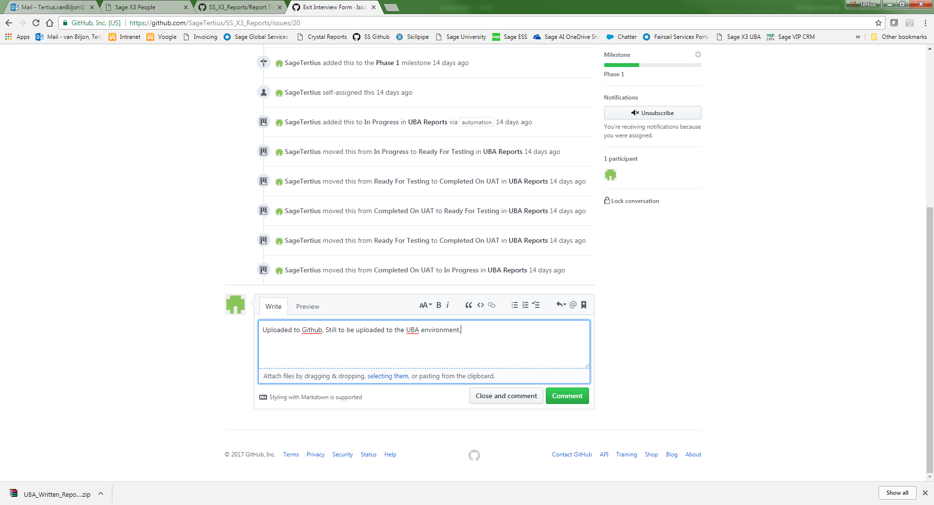

**Note: Once closed, the button above will change to Reopen issue.

If the report is not correct after testing, this button can be selected to move this back to the development step. However details of why the issue is being re-opened must be placed into the comment box.